**Data Preparation steps:**

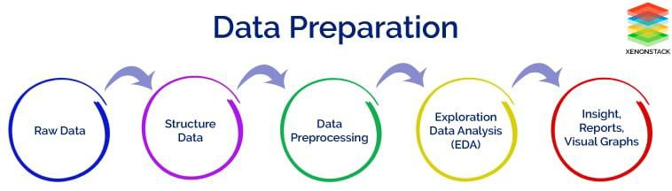

**Data Pre-processing :**

Steps taken to pre process the scraped raw data:

1. Ordinal encoded 'Power Train'

2. Label encoded 'Rapid Charge’

3. Used Label Encoder and Standard Scale package for pre processing of the dataset.

Libraries that’s are necessary in order to perform data analysis and clustering on the collected data, the following Python libraries are used:

* NumPy: It is a Python library used for working with arrays. It also has functions for working in domain of linear algebra, fourier transform, and matrices.
* 2. Pandas: It is a library written for the Python programming language for data manipulation and analysis
* 3. Matplotlib: It is one of the most popular Python packages used for data visualization. It is a cross-platform library for making 2D plots from data in arrays.
* 4. Seaborn: It is an open-source Python library built on top of matplotlib. It is used for data visualization and exploratory data analysis.
* *Importing necessary libraries:*

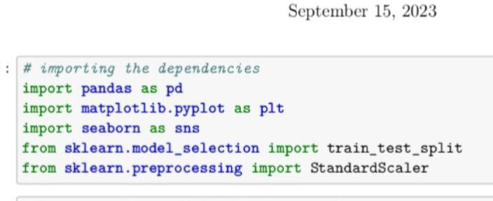

Fig 1 : Importing Important Libraries

* *Reading Datasets:*

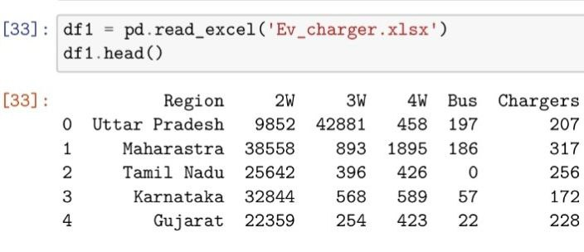

Fig 2 : Reading Datasets

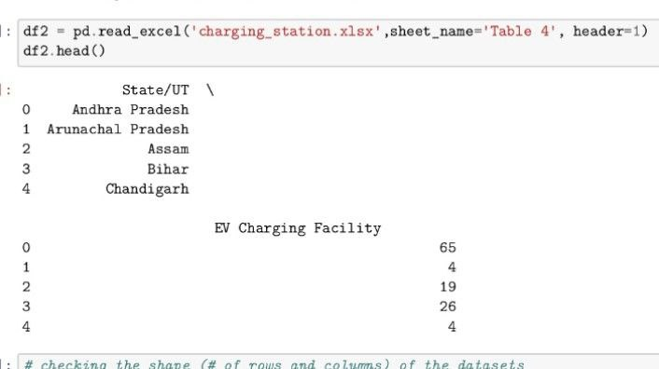

Fig 2 : Reading Datasets

* *Analysing the data*:

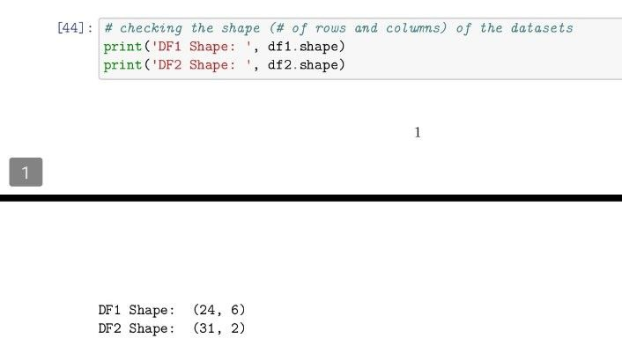

Fig 3: Rows and columns of the dataset

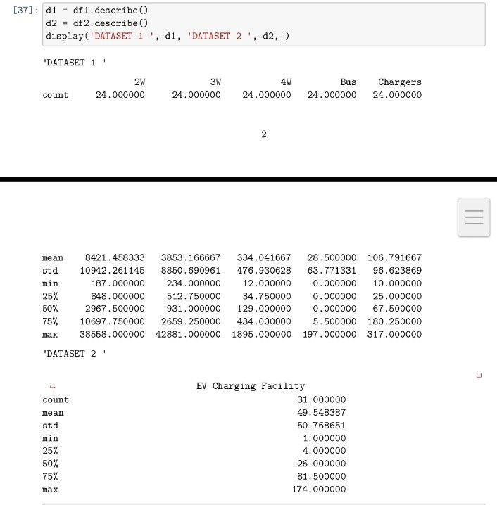

Fig 4: Information in the dataset

**Exploratory Data Analysis:**

Exploratory Data Analysis, popularly abbreviated as EDA, is one of the most important steps in the data science pipeline. It is the process of gaining the information present inside the data with the help of summary statistics and visual representations. Keys features of this technique are presented in the below image .We analyzed our dataset using univariate (analyze data over a single variable/column from a dataset), bivariate (analyze data by taking two variables/columns into consideration from a dataset) and multivariate (analyze data by taking more than two variables/columns into consideration from a dataset) analysis.

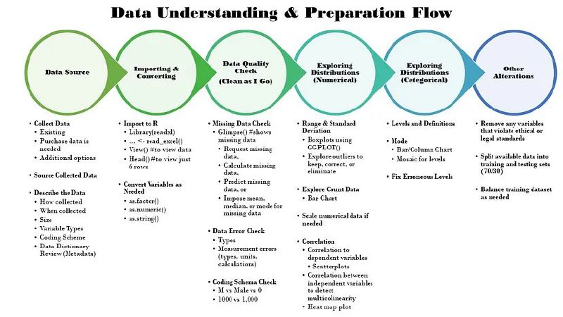

Fig 6: Exploratory Data Analysis

*___________________________________________________________________*

* *Checking for null values in the dataset :*

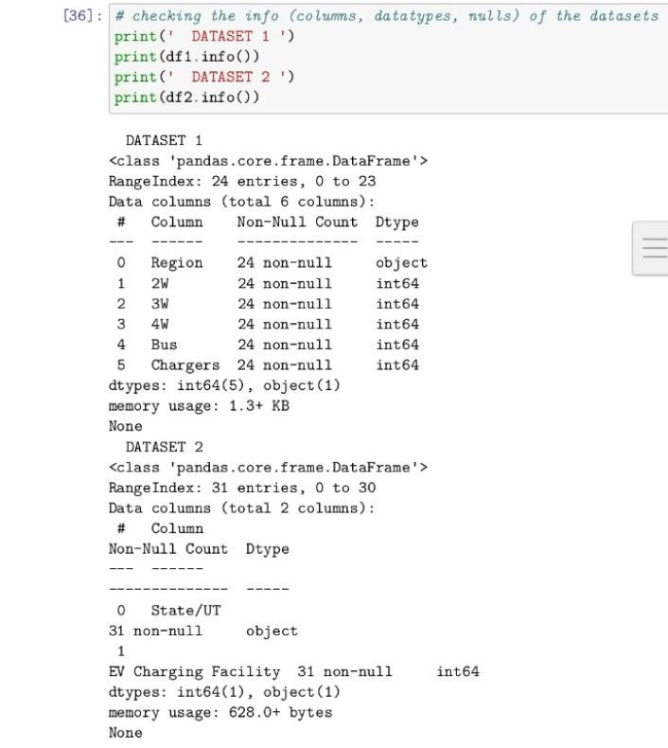

Fig 5: Checking null values

* *Visualization of dataset :*

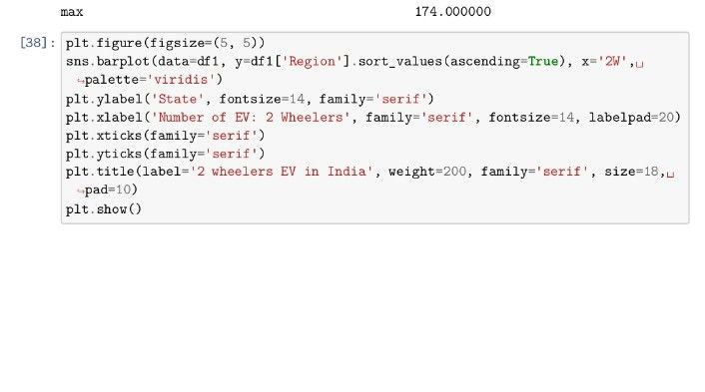

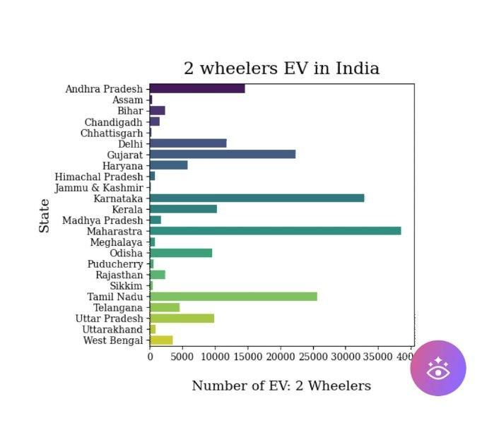

Fig 7: 2 Wheelers EV in India

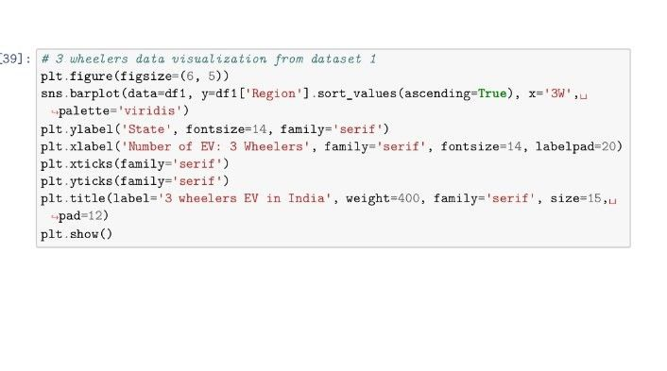

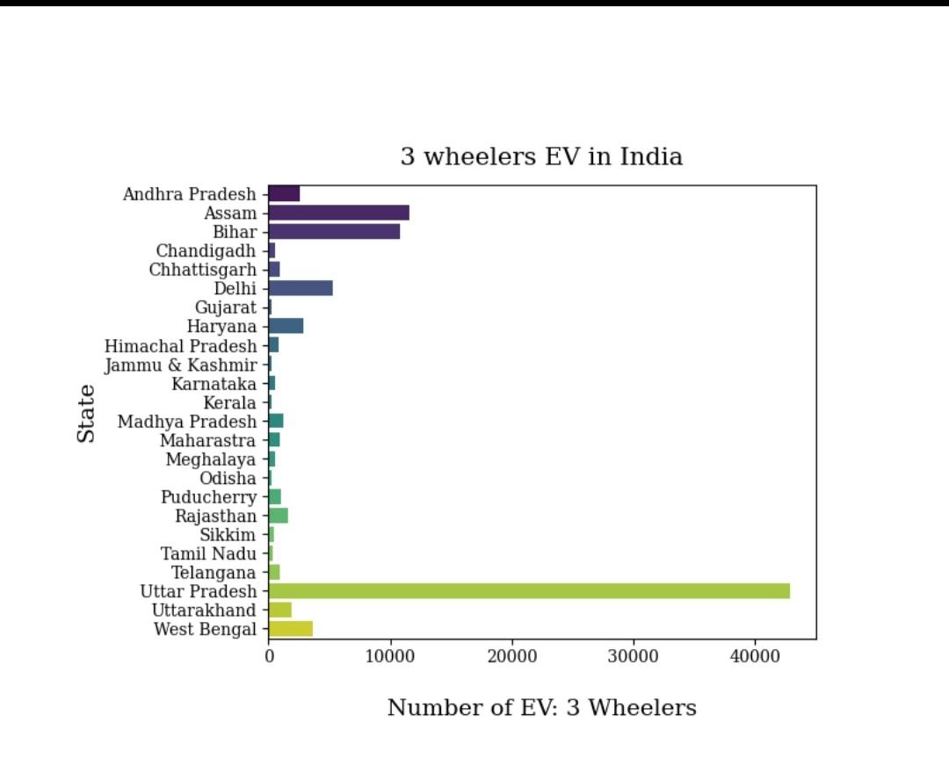

Fig 8: 3 Wheelers EV in India

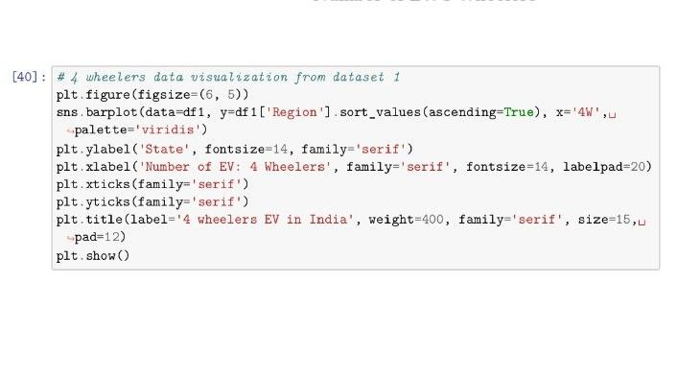

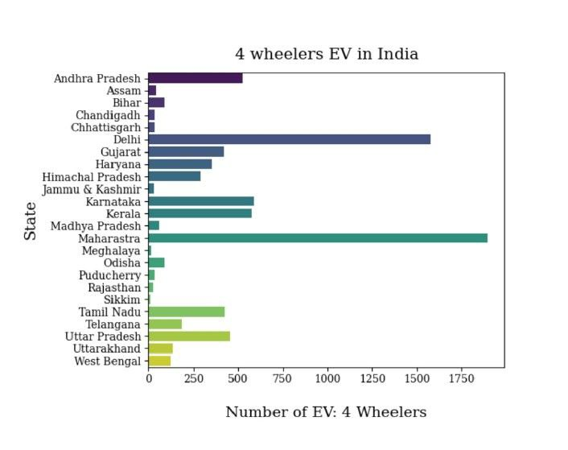

Fig 9: 4 Wheelers EV in India

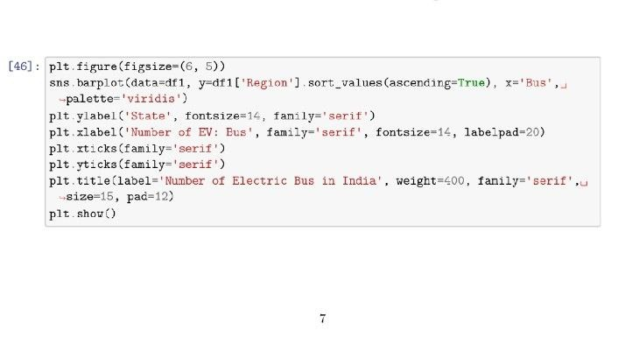

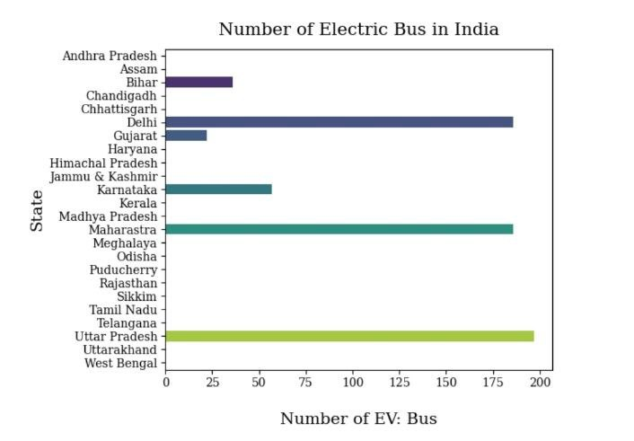

Fig 10: Number Electric Bus in India

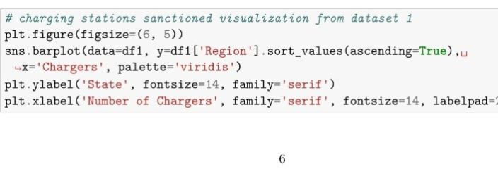

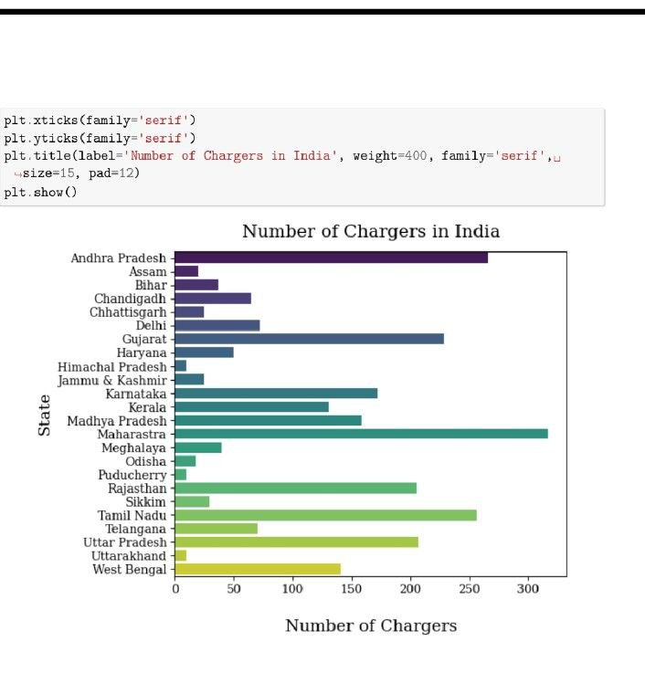

Fig 11: Number of EV Chargers in India

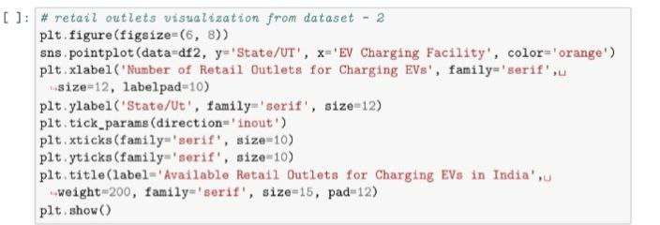

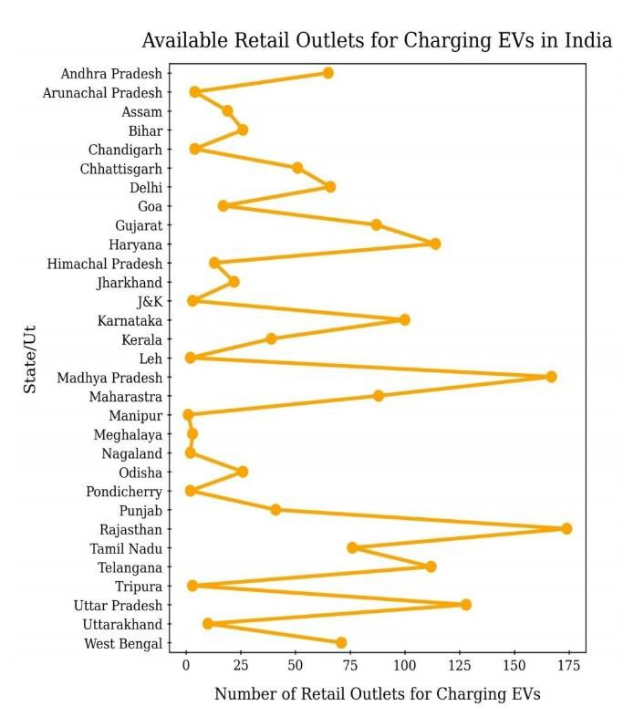

Fig 12: EV Charging Stations